Sr. No | Topic | Page No. | Date
1. | Install Android Studio and Run Hello World App. | 3 | 20/11/2021
2. | Create an android Calculator app with Interactive User Interface using appropriate layouts. | 8 | 20/11/2021
3. | Create an android app that demonstrates working with TextView Elements. | 14 | 25/11/2021
4. | Create an android app that demonstrates Activity Lifecycle and Instance State. | 17 | 27/11/2021
5. | Create an android app that demonstrates the use of Keyboards, Input Controls, Alerts, and Pickers. | 21 | 07/12/2021
6. | Create an android app that demonstrates the use of an Options Menu. | 32 | 09/12/2021
7. | Create an android app that demonstrate Screen Navigation Using the App Bar and Tabs. | 35 | 03/01/2022
8. | Create an android app to Connect to the Internet and use BroadcastReceiver. | 41 | 20/01/2022
9. | Create an android app to show Notifications and Alarm manager. | 45 | 29/01/2022
10. | Create an android app to save user data in a database and use of different queries. | 49

Practical 1:

Aim : Install Android Studio and Run Hello World App.
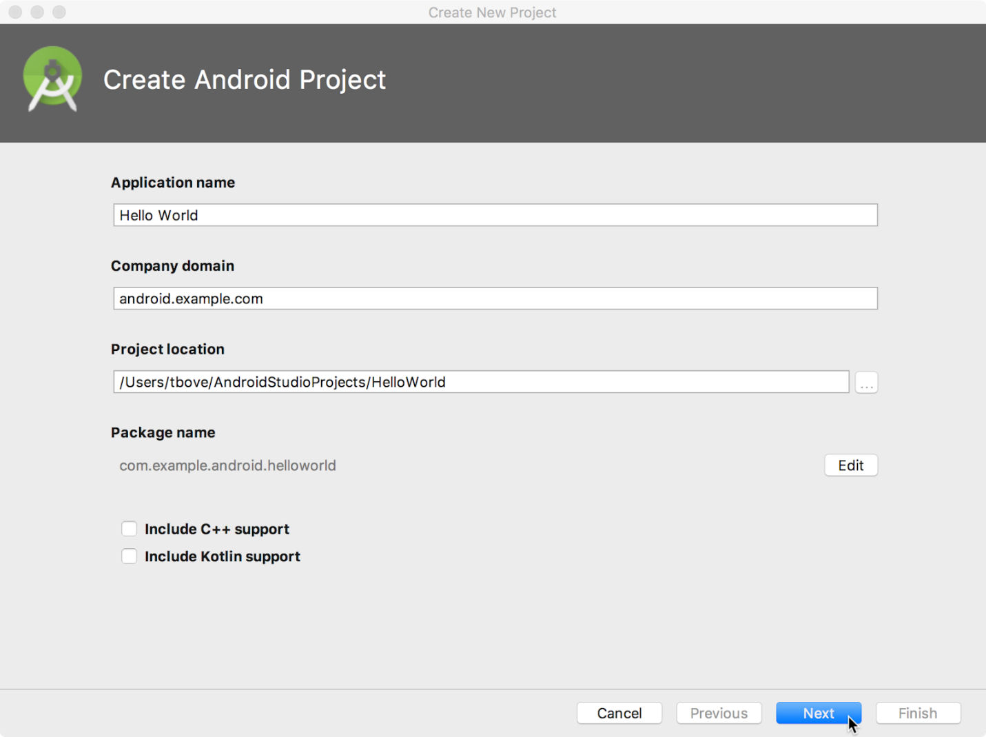

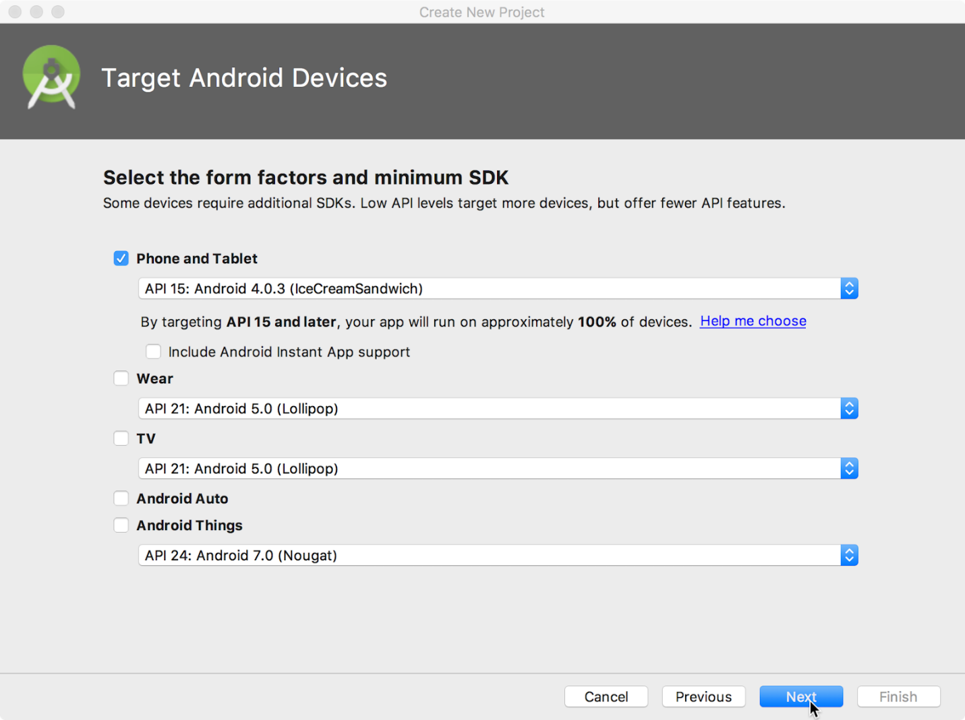.
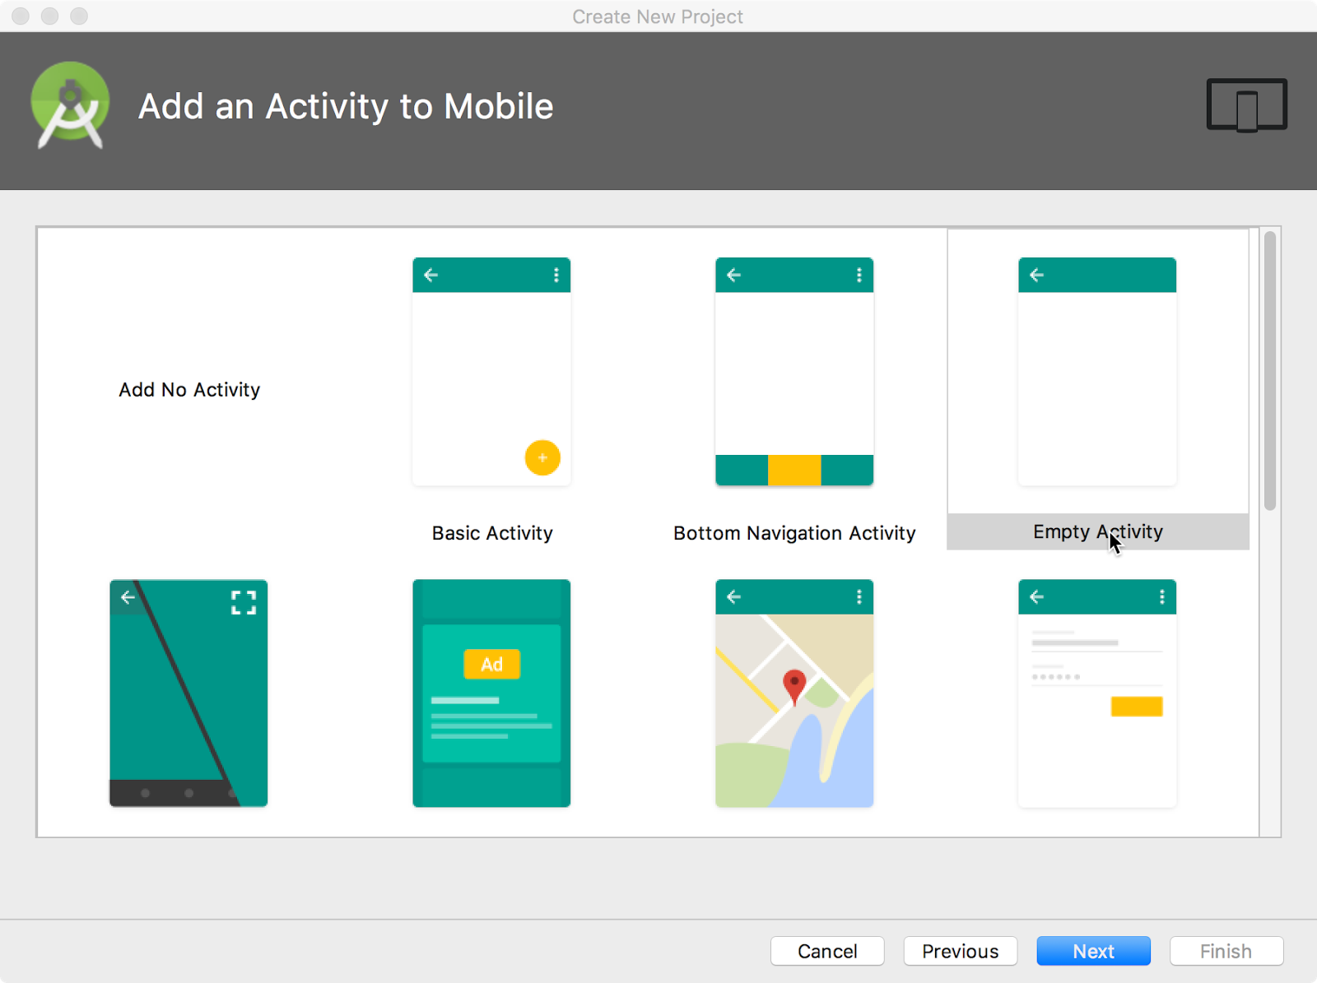
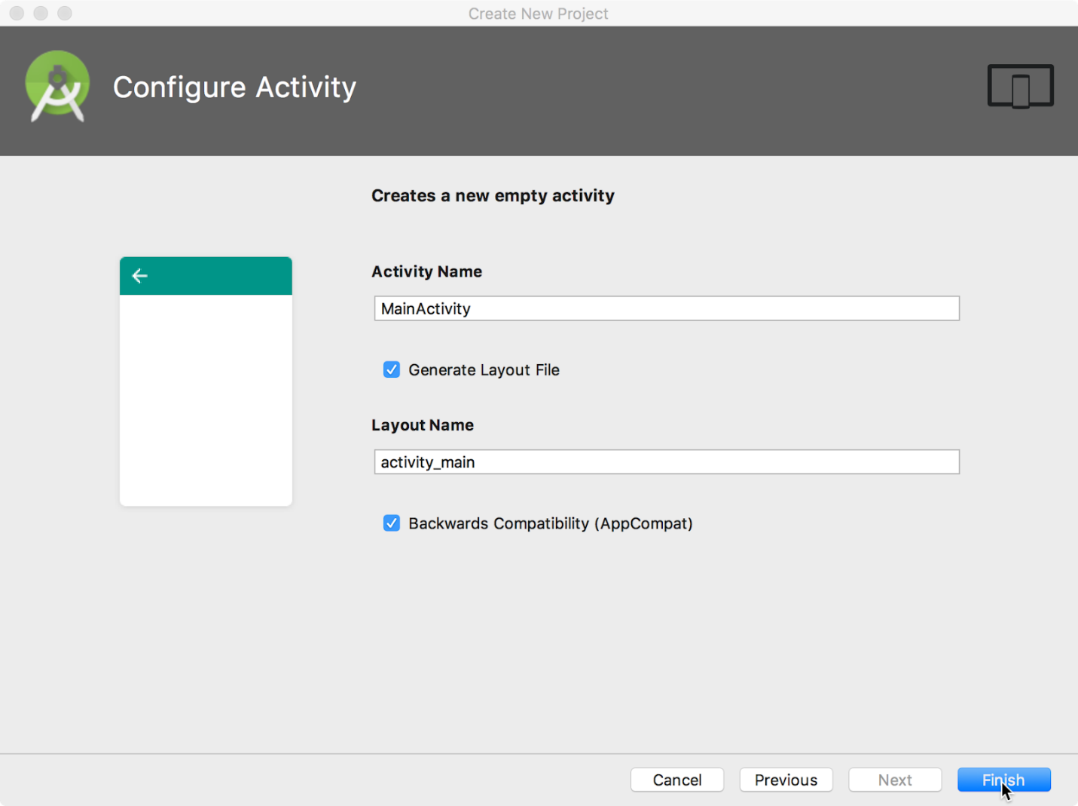
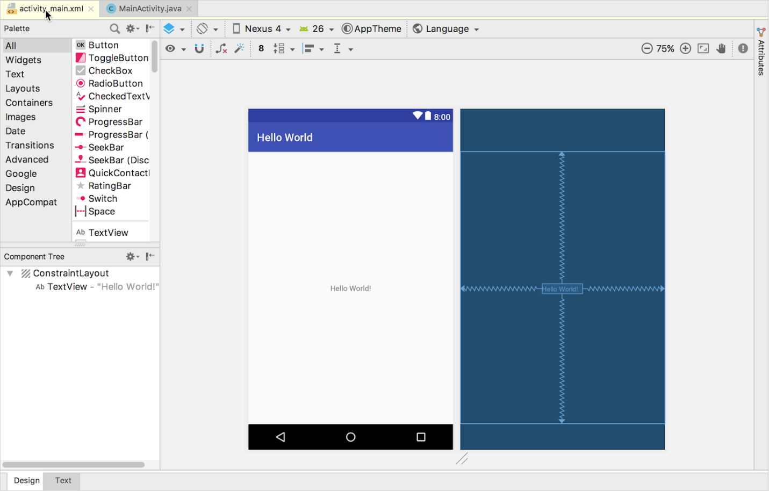

- Click the MainActivity.java tab to see the code editor as shown below.
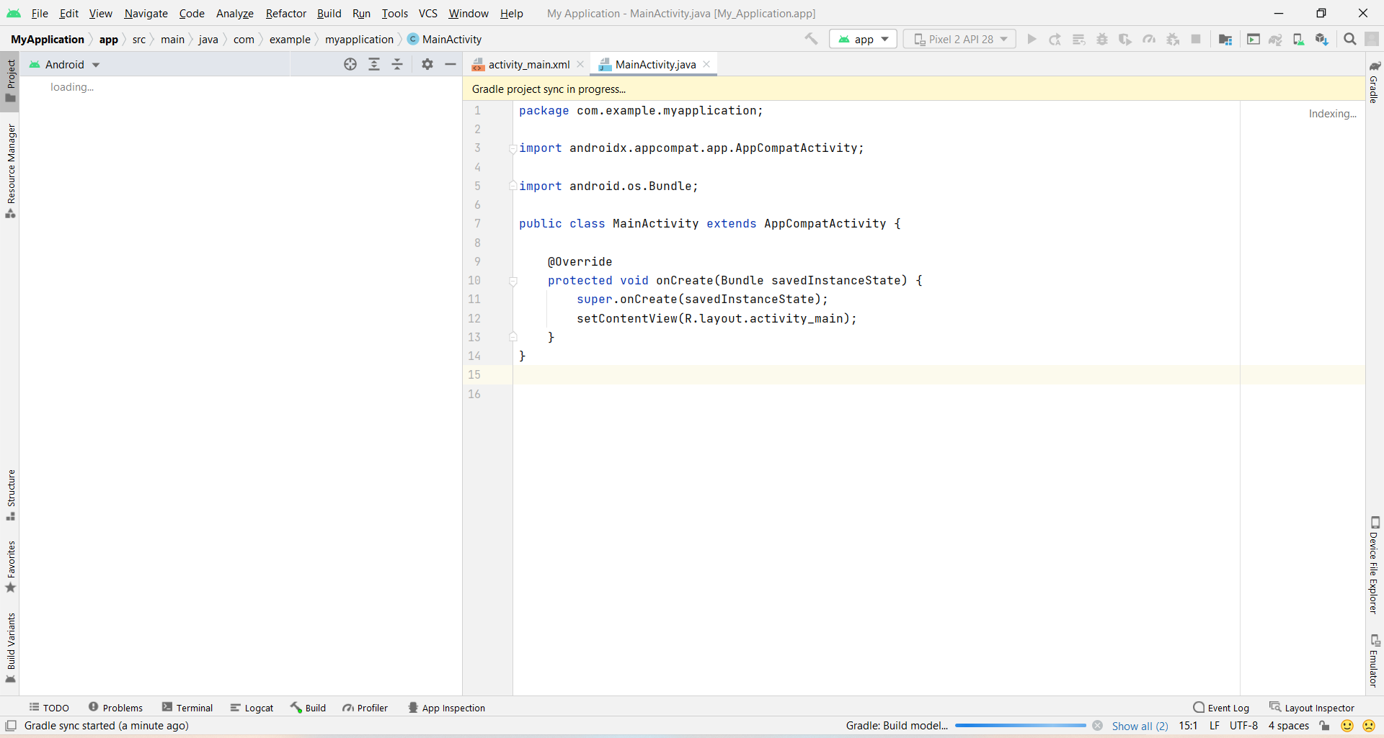

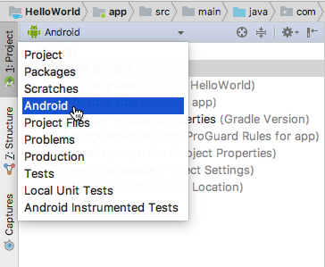
- Click the Activity_Main.xml tab to see the code editor as shown below.
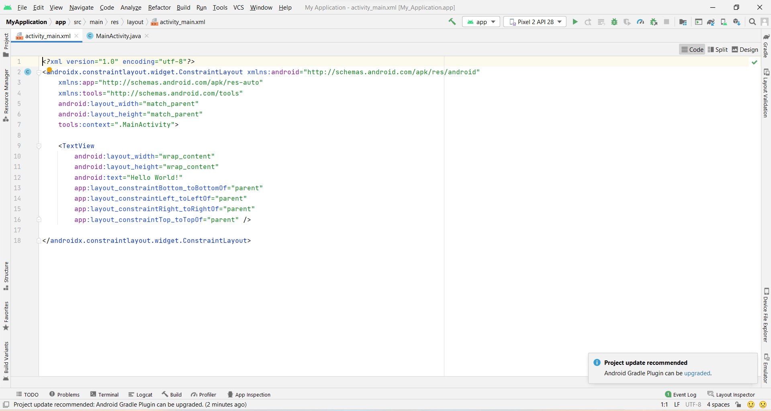

CONCLUSION:
Hence Android Studio is installed in the system successfully.

Practical 2:

Aim : Create an android Calculator app with Interactive User Interface using appropriate layouts.

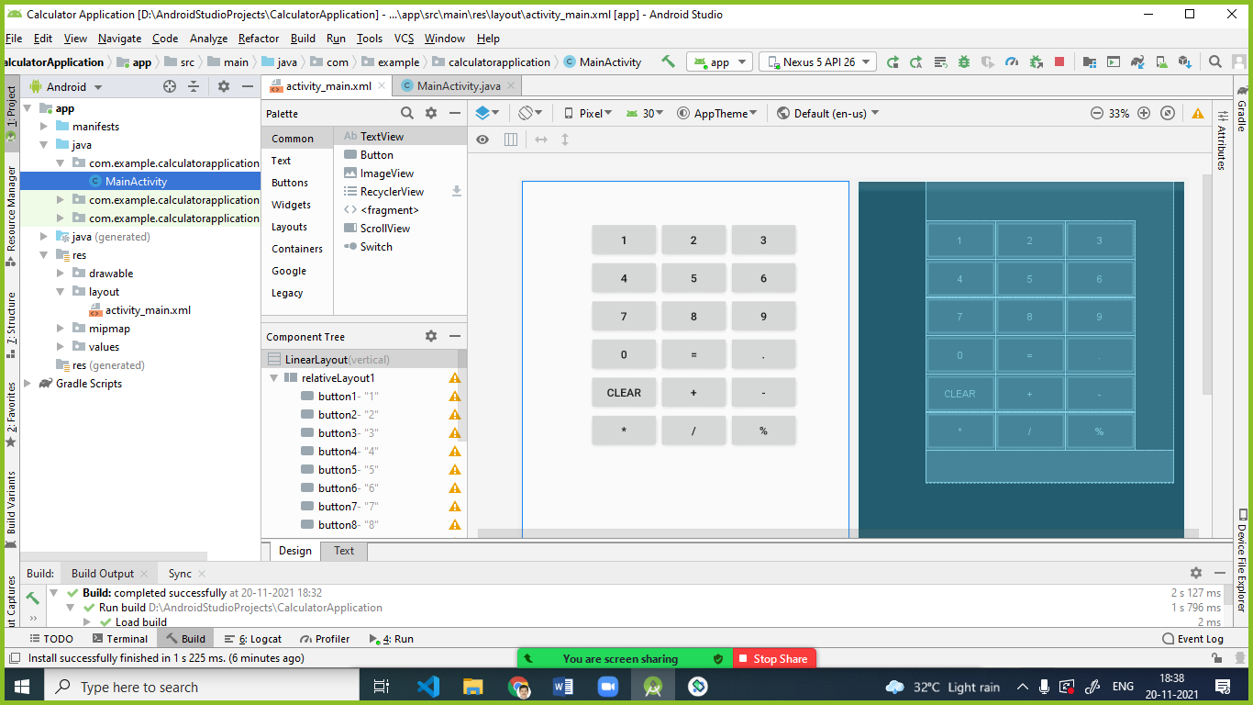
bnutton1

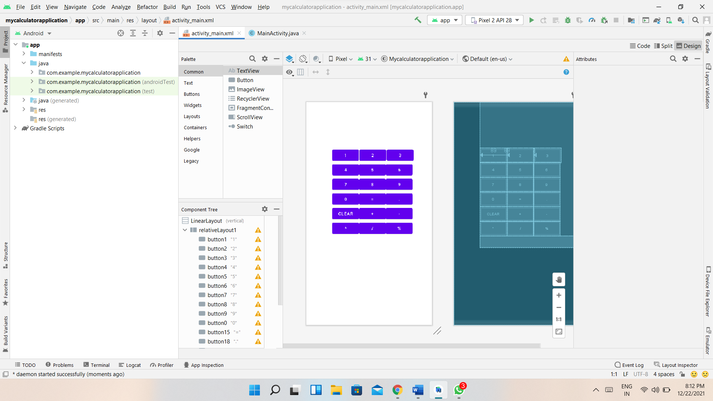

activity_main.xml
<?xml version="1.0" encoding="utf-8"?>
<LinearLayout xmlns:android="http://schemas.android.com/apk/res/android"
android:layout_width="fill_parent"
android:layout_height="fill_parent"
android:orientation="vertical">
<RelativeLayout
android:id="@+id/relativeLayout1"
android:layout_width="312dp"
android:layout_height="wrap_content"
android:layout_gravity="center"
android:layout_marginLeft="35dp">
<Button
android:id="@+id/button1"
android:layout_width="wrap_content"
android:layout_height="wrap_content"
android:layout_alignParentLeft="true"
android:layout_marginTop="150dp"
android:padding="20px"
android:text="1"></Button>
<Button
android:id="@+id/button2"
android:layout_width="wrap_content"
android:layout_height="wrap_content"
android:layout_alignTop="@+id/button1"
android:layout_alignParentLeft="true"
android:layout_marginLeft="89dp"
android:layout_marginTop="0dp"
android:layout_toRightOf="@+id/button1"
android:padding="20px"
android:text="2"></Button>
<Button
android:id="@+id/button3"
android:layout_width="wrap_content"
android:layout_height="wrap_content"
android:layout_alignTop="@+id/button2"
android:layout_marginLeft="2dp"
android:layout_marginTop="0dp"
android:layout_toRightOf="@+id/button2"
android:padding="20px"
android:text="3"></Button>
<Button
android:id="@+id/button4"
android:layout_width="wrap_content"
android:layout_height="wrap_content"
android:layout_alignParentLeft="true"
android:layout_below="@+id/button1"
android:padding="20px"
android:text="4"></Button>
<Button
android:id="@+id/button5"
android:layout_width="wrap_content"
android:layout_height="wrap_content"
android:layout_alignTop="@+id/button4"
android:layout_toRightOf="@+id/button4"
android:padding="20px"
android:text="5"></Button>
<Button
android:id="@+id/button6"
android:layout_width="wrap_content"
android:layout_height="wrap_content"
android:layout_alignTop="@+id/button4"
android:layout_toRightOf="@+id/button5"
android:padding="20px"
android:text="6"></Button>
<Button
android:id="@+id/button7"
android:layout_width="wrap_content"
android:layout_height="wrap_content"
android:layout_alignParentLeft="true"
android:layout_below="@+id/button4"
android:padding="20px"
android:text="7"></Button>
<Button
android:id="@+id/button8"
android:layout_width="wrap_content"
android:layout_height="wrap_content"
android:layout_alignTop="@+id/button7"
android:layout_toRightOf="@+id/button7"
android:padding="20px"
android:text="8"></Button>
<Button
android:id="@+id/button9"
android:layout_width="wrap_content"
android:layout_height="wrap_content"
android:layout_alignTop="@+id/button7"
android:layout_toRightOf="@+id/button8"
android:padding="20px"
android:text="9"></Button>
<Button
android:id="@+id/button0"
android:layout_width="wrap_content"
android:layout_height="wrap_content"
android:layout_alignParentLeft="true"
android:layout_below="@+id/button7"
android:padding="20px"
android:text="0"></Button>
<Button
android:id="@+id/button15"
android:layout_width="wrap_content"
android:layout_height="wrap_content"
android:layout_alignTop="@+id/button0"
android:layout_toRightOf="@+id/button0"
android:padding="20px"
android:text="="></Button>
<Button
android:id="@+id/button18"
android:layout_width="wrap_content"
android:layout_height="wrap_content"
android:layout_alignTop="@+id/button0"
android:layout_toRightOf="@+id/button15"
android:padding="20px"
android:text="."></Button>
<Button
android:id="@+id/button16"
android:layout_width="wrap_content"
android:layout_height="wrap_content"
android:layout_alignParentLeft="true"
android:layout_below="@+id/button0"
android:padding="20px"
android:text="clear"></Button>
<Button
android:id="@+id/button11"
android:layout_width="wrap_content"
android:layout_height="wrap_content"
android:layout_alignTop="@+id/button16"
android:layout_toRightOf="@+id/button16"
android:padding="20px"
android:text="+"></Button>
<Button
android:id="@+id/button12"
android:layout_width="wrap_content"
android:layout_height="wrap_content"
android:layout_alignTop="@+id/button16"
android:layout_toRightOf="@+id/button11"
android:padding="20px"
android:text="-"></Button>
<Button
android:id="@+id/button13"
android:layout_width="wrap_content"
android:layout_height="wrap_content"
android:layout_alignParentLeft="true"
android:layout_below="@+id/button16"
android:padding="20px"
android:text="*"></Button>
<Button
android:id="@+id/button14"
android:layout_width="wrap_content"
android:layout_height="wrap_content"
android:layout_alignTop="@+id/button13"
android:layout_toRightOf="@+id/button13"
android:padding="20px"
android:text="/"></Button>
<Button
android:id="@+id/button17"
android:layout_width="wrap_content"
android:layout_height="wrap_content"
android:layout_alignTop="@+id/button13"
android:layout_toRightOf="@+id/button14"
android:padding="20px"
android:text="%"></Button>
<TextView
android:id="@+id/TextView1"
android:layout_width="fill_parent"
android:layout_height="wrap_content"
android:layout_below="@+id/button13"
android:fontFamily="serif"
android:textSize="30dp"></TextView>
</RelativeLayout>
</LinearLayout>

MainAtivity.java

package com.example.mycalculatorapplication;
import androidx.appcompat.app.AppCompatActivity;
import android.os.Bundle;
import android.view.View;
import android.widget.Button;
import android.widget.TextView;
import android.widget.Toast;
public class MainActivity extends AppCompatActivity {
TextView tv1;
Integer c,d,r,b;
String a = "0", aa;
Button b1,b2,b3,b4,b5,b6,b7,b8,b9,b10,b11,b12,b13,b14,b15,b16,b17,b18;
@Override
protected void onCreate(Bundle savedInstanceState) {
super.onCreate(savedInstanceState);
setContentView(R.layout.activity_main);
tv1 = (TextView) findViewById(R.id.TextView1);
b1 = (Button) findViewById(R.id.button1);
b2 = (Button) findViewById(R.id.button2);
b3 = (Button) findViewById(R.id.button3);
b4 = (Button) findViewById(R.id.button4);
b5 = (Button) findViewById(R.id.button5);
b6 = (Button) findViewById(R.id.button6);
b7 = (Button) findViewById(R.id.button7);
b8 = (Button) findViewById(R.id.button8);
b9 = (Button) findViewById(R.id.button9);
b10 = (Button) findViewById(R.id.button0);
b11 = (Button) findViewById(R.id.button11);
b12 = (Button) findViewById(R.id.button12);
b13 = (Button) findViewById(R.id.button13);
b14= (Button) findViewById(R.id.button14);
b15= (Button) findViewById(R.id.button15);
b16= (Button) findViewById(R.id.button16);
b17= (Button) findViewById(R.id.button17);
b18= (Button) findViewById(R.id.button18);
b1.setOnClickListener(new View.OnClickListener() {
public void onClick(View v) {
a = tv1.getText().toString();
a = a + "1";
tv1.setText(a);
}
});
b2.setOnClickListener(new View.OnClickListener() {
public void onClick(View v) {
a = tv1.getText().toString();
a = a + "2";
tv1.setText(a);
}
});
b3.setOnClickListener(new View.OnClickListener() {
public void onClick(View v) {
a = tv1.getText().toString();
a = a + "3";
tv1.setText(a);
}
});
b4.setOnClickListener(new View.OnClickListener() {
public void onClick(View v) {
a = tv1.getText().toString();
a = a + "4";
tv1.setText(a);
}
});
b5.setOnClickListener(new View.OnClickListener() {
public void onClick(View v) {
a = tv1.getText().toString();
a = a + "5";
tv1.setText(a);
}
});
b6.setOnClickListener(new View.OnClickListener() {
public void onClick(View v) {
a = tv1.getText().toString();
a = a + "6";
tv1.setText(a);
}
});
b7.setOnClickListener(new View.OnClickListener() {
public void onClick(View v) {
a = tv1.getText().toString();
a = a + "7";
tv1.setText(a);
}
});
b8.setOnClickListener(new View.OnClickListener() {
public void onClick(View v) {
a = tv1.getText().toString();
a = a + "8";
tv1.setText(a);
}
});
b9.setOnClickListener(new View.OnClickListener() {
public void onClick(View v) {
a = tv1.getText().toString();
a = a + "9";
tv1.setText(a);
}
});
b10.setOnClickListener(new View.OnClickListener() {
public void onClick(View v) {
a = tv1.getText().toString();
a = a + "0";
tv1.setText(a);
}
});
b11.setOnClickListener(new View.OnClickListener() {
public void onClick(View v) {
aa = a;
b = 1;
a = "";
//tv1.setText(+);
tv1.setText("");
}
});
b12.setOnClickListener(new View.OnClickListener() {
public void onClick(View v) {
aa = a;
b = 2;
a = "";
//tv1.setText(a);
tv1.setText("-");
tv1.setText("");
}
});
b13.setOnClickListener(new View.OnClickListener() {
public void onClick(View v) {
aa = a;
b = 3;
a = "";
//tv1.setText(a);
tv1.setText("*");
tv1.setText("");
}
});
b14.setOnClickListener(new View.OnClickListener() {
public void onClick(View v) {
aa = a;
b = 4;
a = "";
//tv1.setText(a);
tv1.setText("/");
tv1.setText("");
}
});
//OnClickevent handling for =
b15.setOnClickListener(new View.OnClickListener() {
public void onClick(View v) {
if (b == 1){
c = Integer.parseInt(aa);
d = Integer.parseInt(a);
r = c + d;
} else if (b == 4){
c = Integer.parseInt(aa);
d = Integer.parseInt(a);
r = c/d;
} else if (b == 2){
c = Integer.parseInt(aa);
d = Integer.parseInt(a);
r = c - d;
} else if (b == 3) {
c = Integer.parseInt(aa);
d = Integer.parseInt(a);
r = c * d;
}
String op ="";
switch (b) {
case 1: op = " + ";
break;
case 2: op = " - ";
break;
case 3: op = " * ";
break;
case 4: op = " / ";
}
tv1.setText(c + op + d + " = " + r);
String ans=c + op + d + " = " + r;
Toast.makeText(MainActivity.this, ans, Toast.LENGTH_LONG).show();
}
});
b16.setOnClickListener(new View.OnClickListener() {
public void onClick(View v) {
tv1.setText("");
}
});
}
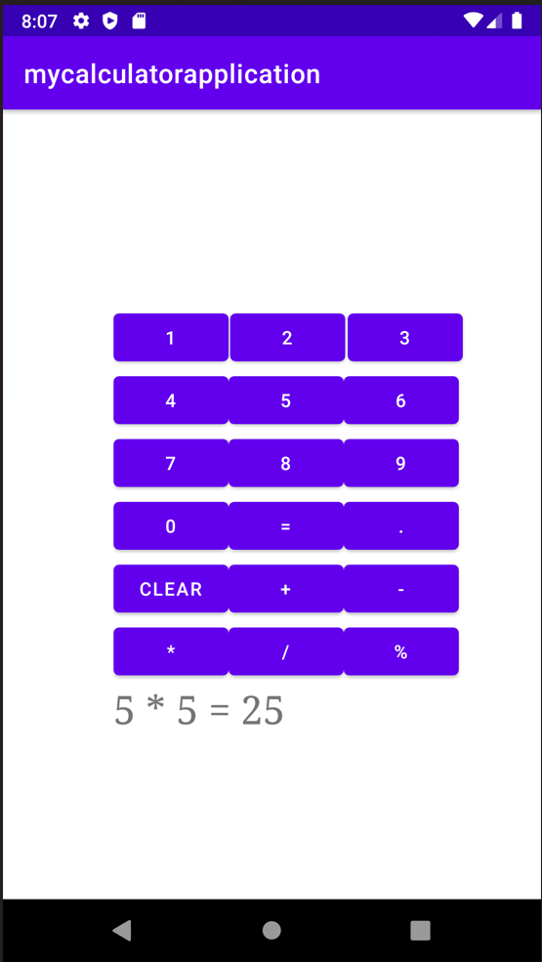
}
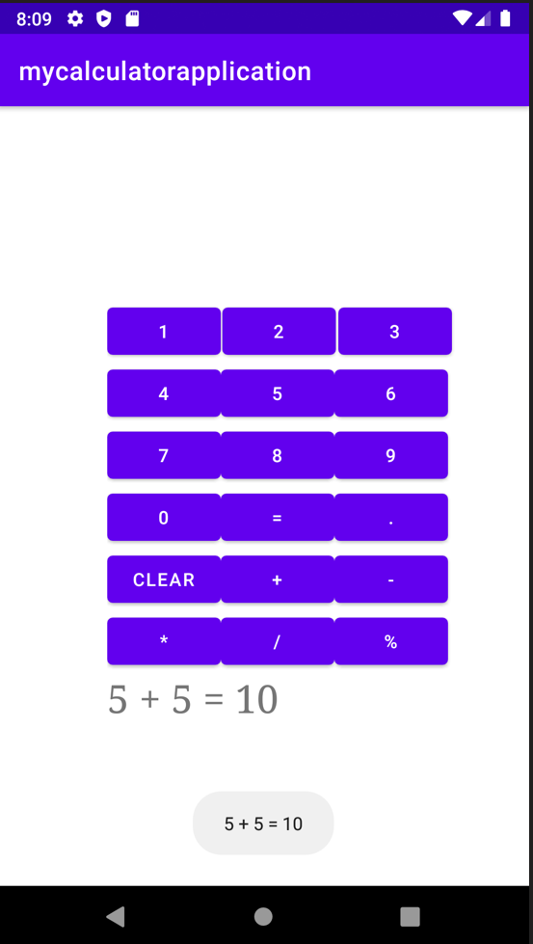
CONCLUSION:
Hence an android Calculator app with Interactive User Interface using appropriate layouts is implemented successfully

Practical 3:

AIM: Create an android app that demonstrates working with TextView Elements.

Code:
<?xmlversion="1.0"encoding="utf-8"?>
<androidx.constraintlayout.widget.ConstraintLayout
xmlns:android="http://schemas.android.com/apk/res/android"
xmlns:app="http://schemas.android.com/apk/res-auto"
xmlns:tools="http://schemas.android.com/tools"
android:layout_width="match_parent"
android:layout_height="match_parent"
tools:context=".MainActivity"
tools:ignore="HardcodedText">

<TextView
android:layout_width="wrap_content"
android:layout_height="wrap_content"
android:text="Hello World"
app:layout_constraintBottom_toBottomOf="parent"
app:layout_constraintLeft_toLeftOf="parent"
app:layout_constraintRight_toRightOf="parent"
app:layout_constraintTop_toTopOf="parent"/>

</androidx.constraintlayout.widget.ConstraintLayout>

.output:
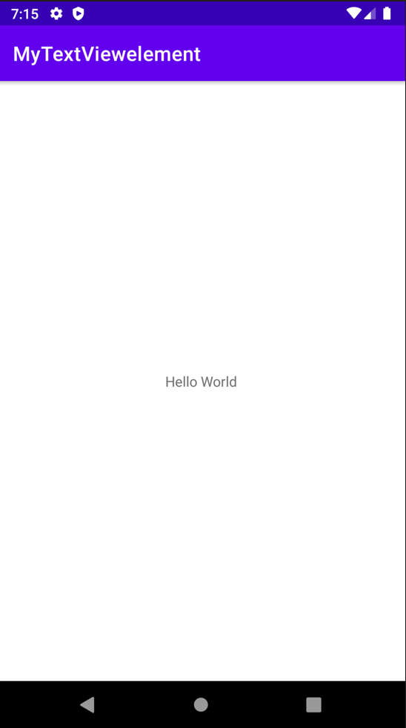

Code:
<?xmlversion="1.0"encoding="utf-8"?>
<androidx.constraintlayout.widget.ConstraintLayout
xmlns:android="http://schemas.android.com/apk/res/android"
xmlns:app="http://schemas.android.com/apk/res-auto"
xmlns:tools="http://schemas.android.com/tools"
android:layout_width="match_parent"
android:layout_height="match_parent"
tools:context=".MainActivity"
tools:ignore="HardcodedText">

<!--the below typeFace attribute has to
invoked with values mentioned-->
<TextView
android:layout_width="wrap_content"
android:layout_height="wrap_content"
android:text="Hello Public"
android:textSize="32sp"

android:typeface="normal"

app:layout_constraintBottom_toBottomOf="parent"
app:layout_constraintLeft_toLeftOf="parent"
app:layout_constraintRight_toRightOf="parent"
app:layout_constraintTop_toTopOf="parent"/>

</androidx.constraintlayout.widget.ConstraintLayout>

Output:
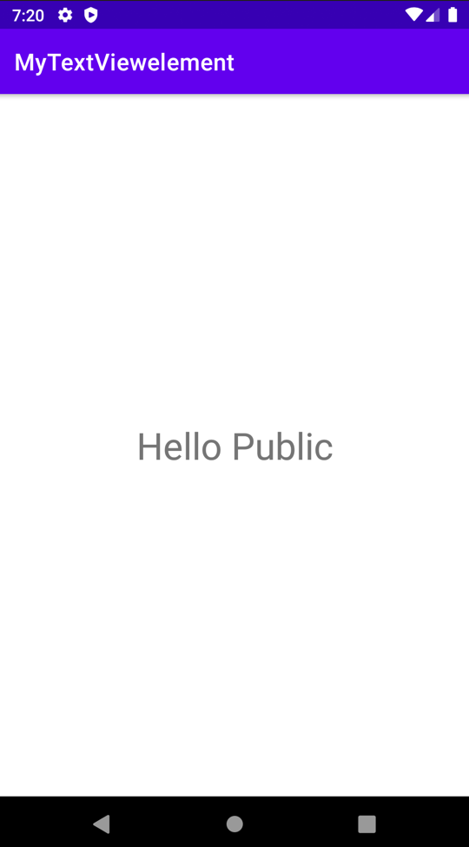

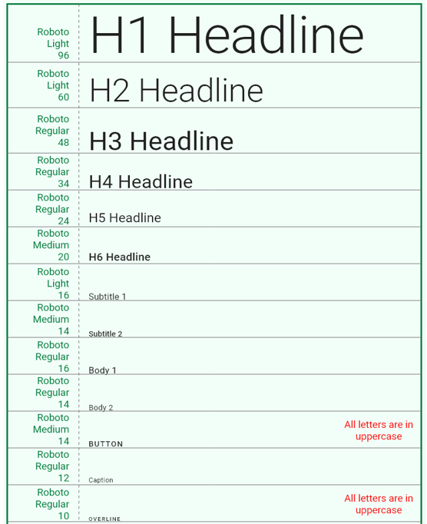

Code:
<?xmlversion="1.0"encoding="utf-8"?>
<LinearLayout
xmlns:android="http://schemas.android.com/apk/res/android"
xmlns:tools="http://schemas.android.com/tools"
android:layout_width="match_parent"
android:layout_height="match_parent"
android:orientation="vertical"
tools:context=".MainActivity"
tools:ignore="HardcodedText">

<TextView
android:layout_width="wrap_content"
android:layout_height="wrap_content"
android:layout_marginStart="32dp"
android:layout_marginTop="64dp"

android:textSize="48sp"

android:text="H3 Heading"/>

<TextView
android:layout_width="wrap_content"
android:layout_height="wrap_content"
android:layout_marginStart="32dp"
android:layout_marginTop="32dp"

android:textSize="32sp"

android:text="H6 Heading"/>

<TextView
android:layout_width="wrap_content"
android:layout_height="wrap_content"
android:layout_marginStart="32dp"
android:layout_marginTop="32dp"

android:textSize="16sp"

android:text="Body 1"/>

<TextView
android:layout_width="wrap_content"
android:layout_height="wrap_content"
android:layout_marginStart="32dp"
android:layout_marginTop="32dp"

android:textSize="14sp"

android:text="Body 2"/>

</LinearLayout>
Output:
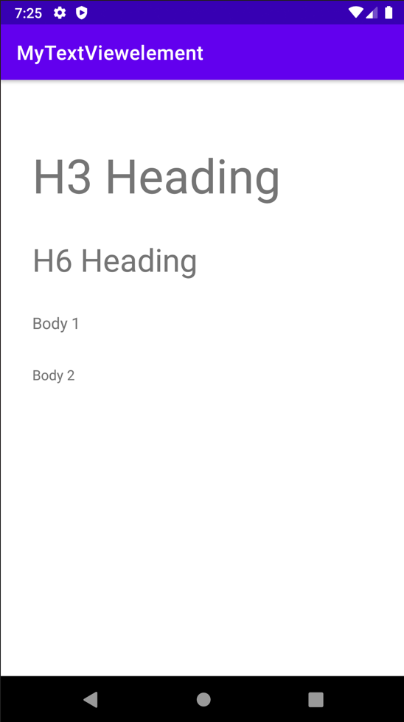

Code:
<?xmlversion="1.0"encoding="utf-8"?>
<LinearLayout
xmlns:android="http://schemas.android.com/apk/res/android"
xmlns:tools="http://schemas.android.com/tools"
android:layout_width="match_parent"
android:layout_height="match_parent"
tools:context=".MainActivity"
tools:ignore="HardcodedText">

<LinearLayout
android:layout_width="match_parent"
android:layout_height="wrap_content"
android:layout_marginStart="32dp"
android:layout_marginTop="32dp"
android:orientation="vertical">

<!--the below textStyle attribute has to
invoked with values mentioned-->
<TextView
android:layout_width="wrap_content"
android:layout_height="wrap_content"
android:text="TCSC World

android:textStyle="italic"

android:textSize="32sp"/>

<TextView
android:layout_width="wrap_content"
android:layout_height="wrap_content"
android:layout_marginTop="32dp"
android:text="TCSC World"

android:textStyle="bold"

android:textSize="32sp"/>

<TextView
android:layout_width="wrap_content"
android:layout_height="wrap_content"
android:layout_marginTop="32dp"
android:text="TCSC World"

android:textStyle="normal"

android:textSize="32sp"/>

<TextView
android:layout_width="wrap_content"
android:layout_height="wrap_content"
android:layout_marginTop="32dp"
android:text="TCSC World"

android:textStyle="bold|italic"

android:textSize="32sp"/>

</LinearLayout>

</LinearLayout>

Output:

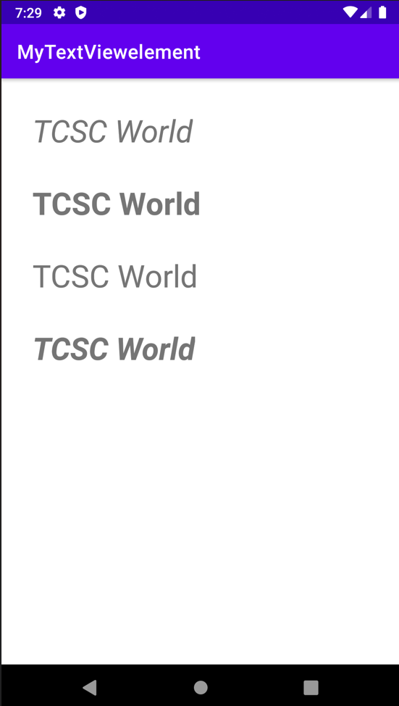

Code:
<?xmlversion="1.0"encoding="utf-8"?>
<LinearLayout
xmlns:android="http://schemas.android.com/apk/res/android"
xmlns:tools="http://schemas.android.com/tools"
android:layout_width="match_parent"
android:layout_height="match_parent"
android:orientation="vertical"
tools:context=".MainActivity"
tools:ignore="HardcodedText">

<!--the value predefined by android-->
<TextView
android:id="@+id/text"
android:layout_width="wrap_content"
android:layout_height="wrap_content"
android:layout_marginStart="32dp"
android:layout_marginTop="64dp"
android:text="Warning Message"
android:textColor="#B00020"
android:textSize="32sp"/>

<!--the value predefined by android-->
<TextView
android:layout_width="wrap_content"
android:layout_height="wrap_content"
android:layout_marginStart="32dp"
android:layout_marginTop="16dp"
android:text="Disabled Text"

android:textColor="@android:color/darker_gray"

android:textSize="32sp"/>

<!--the value is hex code-->
<TextView
android:layout_width="wrap_content"
android:layout_height="wrap_content"
android:layout_marginStart="32dp"
android:layout_marginTop="16dp"
android:text="Hello World"

android:textColor="#000000"

android:textSize="32sp"/>

</LinearLayout>

Output:
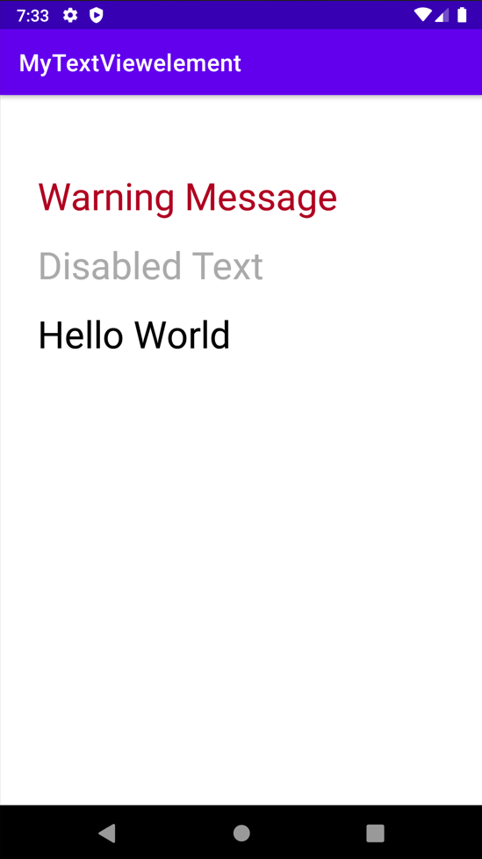
Code:
<?xml version="1.0" encoding="utf-8"?>
<LinearLayout
xmlns:android="http://schemas.android.com/apk/res/android"
xmlns:tools="http://schemas.android.com/tools"
android:layout_width="match_parent"
android:layout_height="match_parent"
android:orientation="vertical"
tools:context=".MainActivity"
tools:ignore="HardcodedText">

<TextView
android:layout_width="wrap_content"
android:layout_height="wrap_content"
android:layout_marginStart="32dp"
android:layout_marginTop="64dp"
android:letterSpacing="0.15"
android:text="GeeksforGeeks"
android:textColor="@android:color/black"
android:textSize="32sp" />

<TextView
android:layout_width="wrap_content"
android:layout_height="wrap_content"
android:layout_marginStart="32dp"
android:layout_marginTop="64dp"
android:text="GeeksforGeeks"
android:textAllCaps="true"
android:textColor="@android:color/black"
android:textSize="32sp" />

</LinearLayout>
Output:
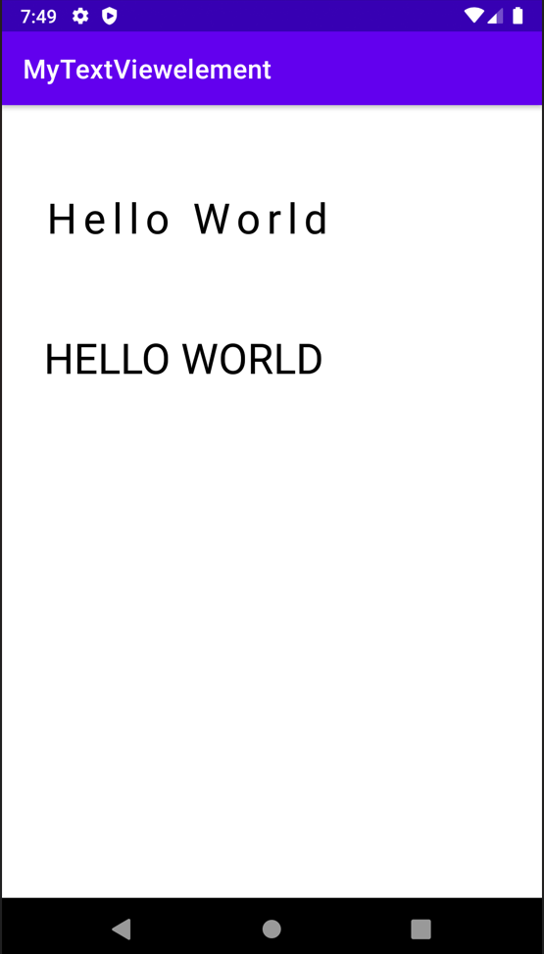

CONCLUSION:
Hence TextView is implemented successfully

Practical 4:

Aim : Create an android app that demonstrates Activity Lifecycle and Instance State.

activity_main.xml
<?xml version="1.0" encoding="utf-8"?>
<androidx.constraintlayout.widget.ConstraintLayoutxmlns:android="http://schemas.android.com/apk/res/android"
xmlns:app="http://schemas.android.com/apk/res-auto"
xmlns:tools="http://schemas.android.com/tools"
android:layout_width="match_parent"
android:layout_height="match_parent"
tools:context=".MainActivity">
<TextView
android:layout_width="wrap_content"
android:layout_height="wrap_content"
android:text="Hello World!"
app:layout_constraintBottom_toBottomOf="parent"
app:layout_constraintLeft_toLeftOf="parent"
app:layout_constraintRight_toRightOf="parent"
app:layout_constraintTop_toTopOf="parent" />
</androidx.constraintlayout.widget.ConstraintLayout>

MainActivity.java
package com.example.mylifecycle;
import androidx.appcompat.app.AppCompatActivity;
import android.os.Bundle;
import android.util.Log;
import android.widget.Toast;
public class MainActivityextends AppCompatActivity{
@Override
protected void onCreate(Bundle savedInstanceState) {
super.onCreate(savedInstanceState);
setContentView(R.layout.activity_main);
Log.d("lifecycle", "TCSC Message: OnCreate invoked");
}
protected void onStart() {
super.onStart();
Log.d("Lifecycle", "TCSC Message: OnStart invoked");
Toast.makeText(this, "I am in OnStart()", Toast.LENGTH_LONG).show();
}
protected void onResume() {
super.onResume();
Toast.makeText(this, "I am in OnResume()", Toast.LENGTH_LONG).show();
Log.d("Lifecycle", "TCSC Message: OnResume invoked");
}
//4431 Saurabh Pal
protected void onPause() {
super.onPause();
Log.d("Lifecycle", "TCSC Message: OnPause invoked");
}
protected void onStop() {
super.onStop();
Log.d("Lifecycle", "TCSC Message: OnStop invoked");
}
protected void onRestart() {
super.onRestart();
Log.d("Lifecycle", "TCSC Message: OnRestart invoked");
}
protected void onDestroy() {
super.onDestroy();
Log.d("Lifecycle", "TCSC Message: OnDestroy invoked");
}
}

Output:
2021-12-2220:42:43.428 6152-6152/com.example.myapplication D/lifecycle: TCSC MEssage: onCreate invoked
2021-12-2220:42:43.440 6152-6152/com.example.myapplication D/lifecycle: TCSC MEssage: onStart invoked
2021-12-2220:42:43.459 6152-6152/com.example.myapplication D/lifecycle: TCSC MEssage: onResume invoked
2021-12-2220:42:52.373 6152-6152/com.example.myapplication D/lifecycle: TCSC MEssage: onPause invoked
2021-12-2220:42:52.384 6152-6152/com.example.myapplication D/lifecycle: TCSC MEssage: onStop invoked
2021-12-2220:42:57.536 6152-6152/com.example.myapplication D/lifecycle: TCSC MEssage: onRestart invoked
2021-12-2221:02:57.537 6152-6152/com.example.myapplication D/lifecycle: TCSC MEssage: onStart invoked
2021-12-2221:03:57.540 6152-6152/com.example.myapplication D/lifecycle: TCSC MEssage: onResume invoked
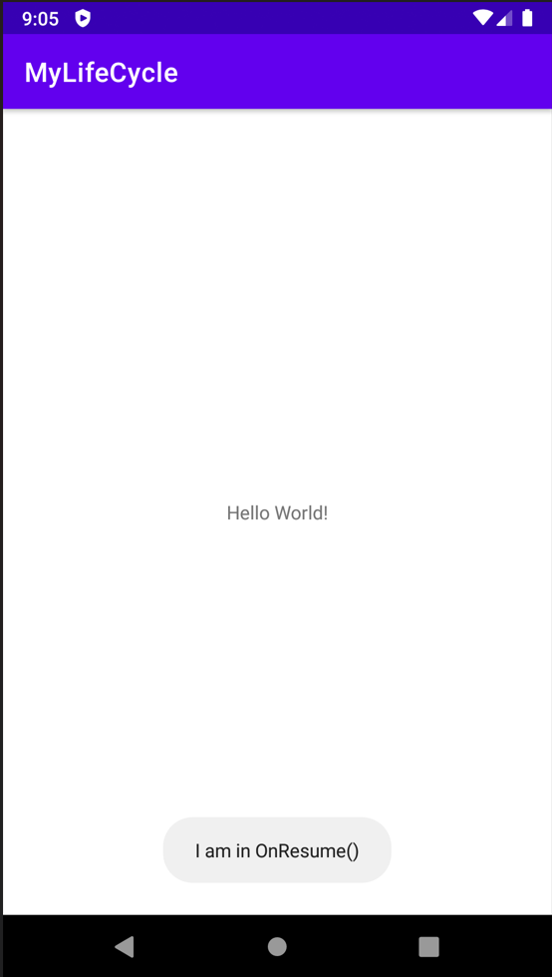

CONCLUSION: Hence an android app that demonstrates Activity Lifecycle and Instance State implemented successfully.

Practical 5:
AIM: Create an android app that demonstrates the use of Keyboards, Input Controls, Alerts, and Pickers.

Theory:

Activity_main.xml
<RelativeLayout
xmlns:android="http://schemas.android.com/apk/res/android"
xmlns:tools="http://schemas.android.com/tools"
android:layout_width="match_parent"
android:layout_height="match_parent"
tools:context="com.example.keyboard.MainActivity">
<Button
android:id="@+id/button_main"
android:layout_width="wrap_content"
android:layout_height="wrap_content"
android:layout_alignParentBottom="true"
android:layout_alignParentRight="true"
android:onClick="showText"
android:text="show" />
<EditText
android:id="@+id/editText_main"
android:layout_width="match_parent"
android:layout_height="wrap_content"
android:layout_alignParentBottom="true"
android:inputType="textPassword"
android:layout_toLeftOf="@id/button_main"
android:hint="enter" />
</RelativeLayout>

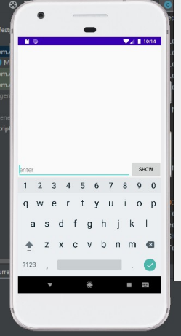
MainActivity.java
package com.example.keyboard;
import android.support.v7.app.AppCompatActivity;
import android.os.Bundle;
import android.view.View;
import android.widget.EditText;
import android.widget.Toast;
public class MainActivity extends AppCompatActivity {
@Override
protected void onCreate(Bundle savedInstanceState) {
super.onCreate(savedInstanceState);
setContentView(R.layout.activity_main);
}
public void showText(View view) {

EditText editText = (EditText) findViewById(R.id.editText_main);
if (editText != null) {
String showString = editText.getText().toString();
Toast.makeText(this, showString, Toast.LENGTH_SHORT).show();
}
}
}

Input Controls
Activity_main.xml
<RelativeLayout
xmlns:android="http://schemas.android.com/apk/res/android"
xmlns:tools="http://schemas.android.com/tools"
android:layout_width="match_parent"
android:layout_height="match_parent"
tools:context="com.example.inputcontrols.MainActivity">
<LinearLayout
android:layout_width="match_parent"
android:layout_height="match_parent"
android:orientation="horizontal">
<EditText
android:id="@+id/editText_main"
android:layout_width="wrap_content"
android:layout_height="wrap_content"
android:inputType="phone"
android:hint="@string/hint_phonenumber" />
<Spinner
android:id="@+id/label_spinner"
android:layout_width="wrap_content"
android:layout_height="wrap_content">
</Spinner>
<Button
android:id="@+id/button_main"
android:layout_width="wrap_content"
android:layout_height="wrap_content"
android:onClick="showText"
android:text="@string/show_button" />
</LinearLayout>
<LinearLayout
android:layout_width="wrap_content"
android:layout_height="wrap_content"
android:orientation="horizontal"
android:layout_alignParentBottom="true">
<TextView
android:id="@+id/title_phonelabel"
android:layout_width="wrap_content"
android:layout_height="wrap_content"
android:text="@string/phonenumber_label"/>
<TextView
android:id="@+id/text_phonelabel"
android:layout_width="wrap_content"
android:layout_height="wrap_content"
android:text="@string/nothing_entered"/>

</LinearLayout>
</RelativeLayout>

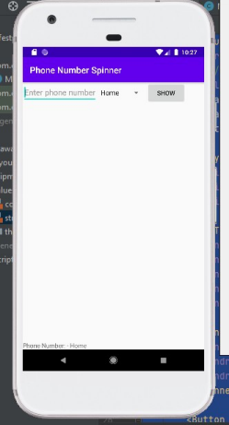
MainActivity.java
package com.example.inputcontrols;
import android.support.v7.app.AppCompatActivity;
import android.os.Bundle;
import android.util.Log;
import android.view.View;
import android.widget.AdapterView;
import android.widget.ArrayAdapter;
import android.widget.EditText;
import android.widget.Spinner;
import android.widget.TextView;
import android.widget.Toast;

import android.widget.AdapterView;
public class MainActivity extends AppCompatActivity implements
AdapterView.OnItemSelectedListener {
private static final String TAG = MainActivity.class.getSimpleName();
private String mSpinnerLabel = "";
@Override
protected void onCreate(Bundle savedInstanceState) {
super.onCreate(savedInstanceState);
setContentView(R.layout.activity_main);
Spinner spinner = (Spinner) findViewById(R.id.label_spinner);
if (spinner != null) {
spinner.setOnItemSelectedListener(this);
}
ArrayAdapter<CharSequence> adapter = ArrayAdapter.createFromResource(this, R.array.labels_array, android.R.layout.simple_spinner_item);
adapter.setDropDownViewResource(android.R.layout.simple_spinner_dropdown_item); if (spinner != null) {
spinner.setAdapter(adapter);
}
}
public void showText(View view) {
EditText editText = (EditText) findViewById(R.id.editText_main);
if (editText != null) {
String showString = (editText.getText().toString() + " - " + mSpinnerLabel); Toast.makeText(this, showString, Toast.LENGTH_SHORT).show();
TextView textView = (TextView)findViewById(R.id.text_phonelabel); textView.setText(showString);
}
}
@Override
public void onItemSelected(AdapterView<?> adapterView, View view, int i, long l) { mSpinnerLabel = adapterView.getItemAtPosition(i).toString();
showText(view);
}
@Override
public void onNothingSelected(AdapterView<?> adapterView) {
Log.d(TAG, getString(R.string.nothing_selected));
}
}

Date Time Picker
Activity_main.xml
<?xml version="1.0" encoding="utf-8"?>
<LinearLayout xmlns:android="http://schemas.android.com/apk/res/android" xmlns:tools="http://schemas.android.com/tools"
android:orientation="vertical"
android:layout_width="match_parent"
android:layout_height="match_parent"
tools:context="com.example.picker.MainActivity">
<TextView
android:layout_width="wrap_content"
android:layout_height="wrap_content"
android:text="choose date time"/>
<RelativeLayout
android:layout_width="match_parent"
android:layout_height="match_parent">
<Button
android:layout_width="wrap_content"
android:layout_height="wrap_content"
android:id="@+id/button_date"
android:text="date"
android:onClick="showDatePickerDialog"/>
<Button
android:layout_width="wrap_content"
android:layout_height="wrap_content"
android:id="@+id/button_time"
android:layout_alignBottom="@id/button_date"
android:layout_toRightOf="@id/button_date"
android:text="time"
android:onClick="showTimePickerDialog"/>
</RelativeLayout>
</LinearLayout>

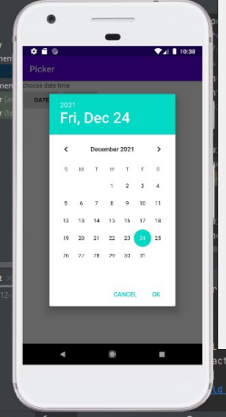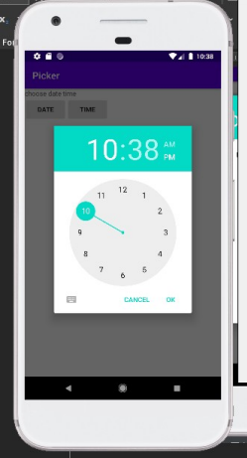MainActivity.java
package com.example.picker;
import android.support.v4.app.DialogFragment;
import android.support.v7.app.AppCompatActivity;
import android.os.Bundle;
import android.view.View;
import android.widget.Toast;
public class MainActivity extends AppCompatActivity {
@Override
protected void onCreate(Bundle savedInstanceState) {
super.onCreate(savedInstanceState);
setContentView(R.layout.activity_main);
}
public void showDatePickerDialog(View view) {

DialogFragment newFragment = new DatePickerFragment();
newFragment.show(getSupportFragmentManager(),
getString(R.string.date_picker));
}
public void showTimePickerDialog(View view) {
DialogFragment newFragment = new TimePickerFragment();
newFragment.show(getSupportFragmentManager(),
getString(R.string.time_picker));
}
public void processDatePickerResult(int year, int month, int day) {
String month_string = Integer.toString(month+1);
String day_string = Integer.toString(day);
String year_string = Integer.toString(year);
String dateMessage = (month_string + "/" +
day_string + "/" + year_string);
Toast.makeText(this, getString(R.string.date) + dateMessage,
Toast.LENGTH_SHORT).show();
}
public void processTimePickerResult(int hourOfDay, int minute) {
String hour_string = Integer.toString(hourOfDay);
String minute_string = Integer.toString(minute);
String timeMessage = (hour_string + ":" + minute_string);
Toast.makeText(this, getString(R.string.time) + timeMessage,
Toast.LENGTH_SHORT).show();
}
}

DatePickerFragment.java
package com.example.picker;
import android.app.Dialog;
import android.os.Bundle;
import android.support.annotation.NonNull;
import android.support.v4.app.Fragment;
import android.text.format.DateFormat;
import android.support.v4.app.DialogFragment;
import android.app.TimePickerDialog;
import android.widget.TimePicker;
import java.util.Calendar;
/**
* A simple {@link Fragment} subclass.
*/
public class TimePickerFragment extends DialogFragment
implements TimePickerDialog.OnTimeSetListener {
@NonNull
@Override
public Dialog onCreateDialog(Bundle savedInstanceState) {
// Use the current time as the default values for the picker.
final Calendar c = Calendar.getInstance();
int hour = c.get(Calendar.HOUR_OF_DAY);
int minute = c.get(Calendar.MINUTE);

// Create a new instance of TimePickerDialog and return it.
return new TimePickerDialog(getActivity(), this, hour, minute,
DateFormat.is24HourFormat(getActivity()));
}
public void onTimeSet(TimePicker view, int hourOfDay, int minute) {
// Do something with the time chosen by the user.
// Set the activity to the Main Activity.
MainActivity activity = (MainActivity) getActivity();
// Invoke Main Activity's processTimePickerResult() method.
activity.processTimePickerResult(hourOfDay, minute);
}
}

TimePickerFragment.java
package com.example.picker;
import android.app.Dialog;
import android.os.Bundle;
import android.support.annotation.NonNull;
import android.support.v4.app.Fragment;
import android.text.format.DateFormat;
import android.support.v4.app.DialogFragment;
import android.app.TimePickerDialog;
import android.widget.TimePicker;
import java.util.Calendar;
/**
* A simple {@link Fragment} subclass.
*/
public class TimePickerFragment extends DialogFragment
implements TimePickerDialog.OnTimeSetListener {
@NonNull
@Override
public Dialog onCreateDialog(Bundle savedInstanceState) {
// Use the current time as the default values for the picker.
final Calendar c = Calendar.getInstance();
int hour = c.get(Calendar.HOUR_OF_DAY);
int minute = c.get(Calendar.MINUTE);
// Create a new instance of TimePickerDialog and return it.
return new TimePickerDialog(getActivity(), this, hour, minute,
DateFormat.is24HourFormat(getActivity()));
}
public void onTimeSet(TimePicker view, int hourOfDay, int minute) { // Do something with the time chosen by the user.
// Set the activity to the Main Activity.
MainActivity activity = (MainActivity) getActivity();
// Invoke Main Activity's processTimePickerResult() method.

activity.processTimePickerResult(hourOfDay, minute);
}
}

CONCLUSION: Hence an app that demonstrates the use of Keyboard, Input Controls, Alerts, and Pickers.(e.g. Droid café) is implemented successfully.

Practical 6:

Aim : Create an android app that demonstrates the use of an Options Menu.

Mainactivity.java
package com.example.optionmenu1;
import android.os.Bundle;
import com.google.android.material.snackbar.Snackbar;
import androidx.appcompat.app.AppCompatActivity;
import android.view.View;
import androidx.navigation.NavController;
import androidx.navigation.Navigation;
import androidx.navigation.ui.AppBarConfiguration;
import androidx.navigation.ui.NavigationUI;
import com.example.optionmenu1.databinding.ActivityMainBinding;
import android.view.Menu;
import android.view.MenuItem;
import android.os.Bundle;
import android.view.Menu;
import android.view.MenuItem;
import android.widget.Toast;
import androidx.appcompat.app.AppCompatActivity;
import androidx.appcompat.widget.Toolbar;
public class MainActivityextends AppCompatActivity{
@Override
protected void onCreate(Bundle savedInstanceState) {
super.onCreate(savedInstanceState);
setContentView(R.layout.activity_main);
Toolbar toolbar= findViewById(R.id.toolbar);
setSupportActionBar(toolbar);
}
@Override
public booleanonCreateOptionsMenu(Menu menu) {
// Inflate the menu; this adds items to the action bar if it is present.
getMenuInflater().inflate(R.menu.menu_main, menu);
return true;
}
@Override
public booleanonOptionsItemSelected(MenuItemitem) {
// Handle action bar item clicks here. The action bar will
// automatically handle clicks on the Home/Up button, so long
// as you specify a parent activity in AndroidManifest.xml.
int id = item.getItemId();
switch (id) {
case R.id.item1:
Toast.makeText(getApplicationContext(), "Your favorite Subjects ", Toast.LENGTH_LONG).show();
return true;
case R.id.item2:
Toast.makeText(getApplicationContext(), "You like Data Science ", Toast.LENGTH_LONG).show();
return true;
case R.id.item3:
Toast.makeText(getApplicationContext(), "Is Java is your favourite", Toast.LENGTH_LONG).show();
return true;
case R.id.item4:
Toast.makeText(getApplicationContext(), "You selected Algorithm ", Toast.LENGTH_LONG).show();
return true;
case R.id.item5:
Toast.makeText(getApplicationContext(), " Android is favorite ", Toast.LENGTH_LONG).show();
return true;
case R.id.item6:
Toast.makeText(getApplicationContext(), " Dsp selected ", Toast.LENGTH_LONG).show();
return true;
default:
return super.onOptionsItemSelected(item);
}
}
}
content_main.xml
<?xml version="1.0" encoding="utf-8"?>
<androidx.constraintlayout.widget.ConstraintLayoutxmlns:android="http://schemas.android.com/apk/res/android"
xmlns:app="http://schemas.android.com/apk/res-auto"
android:layout_width="match_parent"
android:layout_height="match_parent"
app:layout_behavior="@string/appbar_scrolling_view_behavior">
<fragment
android:id="@+id/nav_host_fragment_content_main"
android:name="androidx.navigation.fragment.NavHostFragment"
android:layout_width="0dp"
android:layout_height="0dp"
app:defaultNavHost="true"
app:layout_constraintBottom_toBottomOf="parent"
app:layout_constraintHorizontal_bias="1.0"
app:layout_constraintLeft_toLeftOf="parent"
app:layout_constraintRight_toRightOf="parent"
app:layout_constraintTop_toTopOf="parent"
app:layout_constraintVertical_bias="0.0"
app:navGraph="@navigation/nav_graph" />
</androidx.constraintlayout.widget.ConstraintLayout>
menu_main.xml

<menu xmlns:android="http://schemas.android.com/apk/res/android"
xmlns:app="http://schemas.android.com/apk/res-auto"
xmlns:tools="http://schemas.android.com/tools"
tools:context="com.example.optionmenu1.MainActivity">
<item android:id="@+id/item1"
android:title="SUBJECTS::"/>
<item android:id="@+id/item2"
android:title="Data Science"/>
<item android:id="@+id/item3"
android:title="Java"/>
<item android:id="@+id/item4"
android:title="Algorithm"/>
<item android:id="@+id/item5"
android:title="Android"/>
<item android:id="@+id/item6"
android:title="Dsp"/>
</menu>

activity_main.xml

<?xml version="1.0" encoding="utf-8"?>
<androidx.coordinatorlayout.widget.CoordinatorLayoutxmlns:android="http://schemas.android.com/apk/res/android"
xmlns:app="http://schemas.android.com/apk/res-auto"
xmlns:tools="http://schemas.android.com/tools"
android:layout_width="match_parent"
android:layout_height="match_parent"
tools:context=".MainActivity">
<com.google.android.material.appbar.AppBarLayout
android:layout_width="match_parent"
android:layout_height="wrap_content"
android:theme="@style/Theme.OptionMenu1.AppBarOverlay">
<androidx.appcompat.widget.Toolbar
android:id="@+id/toolbar"
android:layout_width="match_parent"
android:layout_height="wrap_content"
android:background="@color/teal_200"
app:popupTheme="@style/Theme.OptionMenu1.PopupOverlay"/>
</com.google.android.material.appbar.AppBarLayout>
<!--<include layout="@layout/content_main" /> -->
<TextView
android:layout_width="wrap_content"
android:layout_height="wrap_content"
android:text="WELCOME" />
</androidx.coordinatorlayout.widget.CoordinatorLayout>

Output-
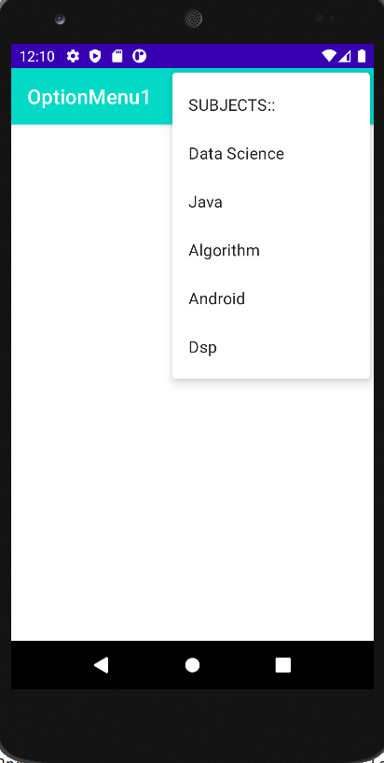

CONCLUSION:
Hence Option Menu is implemented successfully

Practical 7:

Aim : Create an android app that demonstrate Screen Navigation Using the App Bar and Tabs.
:
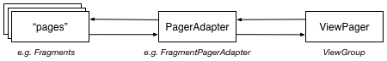
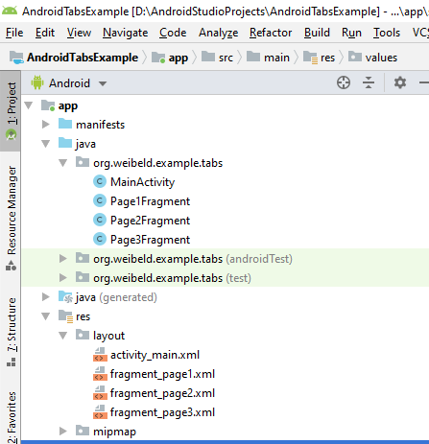

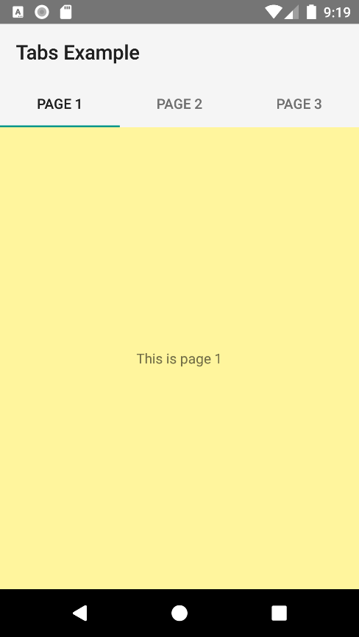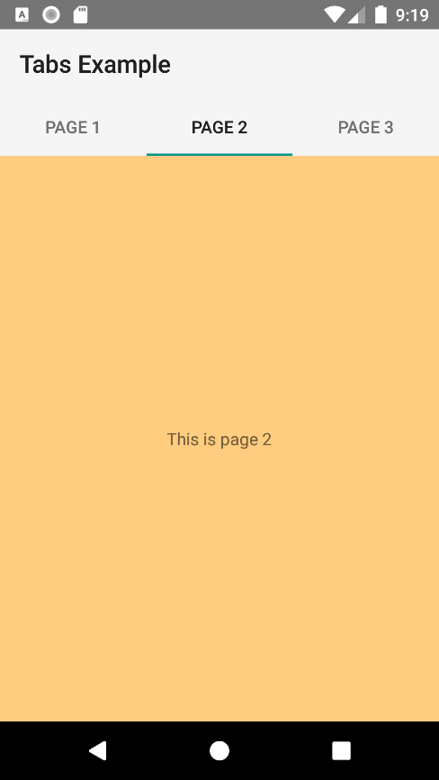
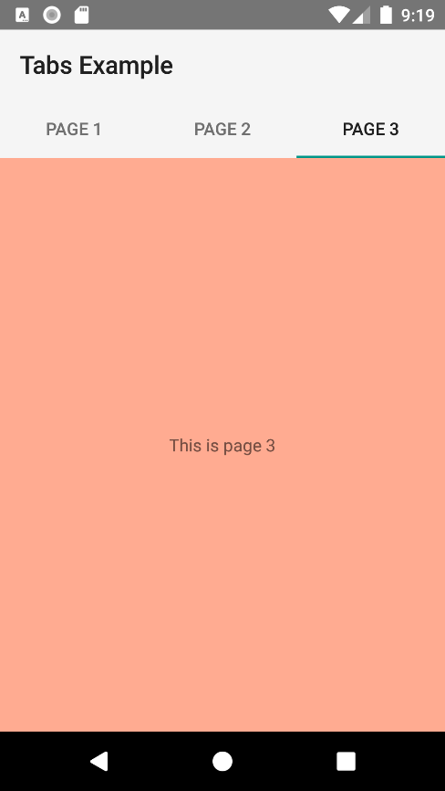

activity_main.xml
<?xml version="1.0" encoding="utf-8"?>
<LinearLayout
xmlns:android="http://schemas.android.com/apk/res/android"
xmlns:tools="http://schemas.android.com/tools"
android:id="@+id/activity_main"
android:layout_width="match_parent"
android:layout_height="match_parent"
android:orientation="vertical"
tools:context="org.weibeld.example.tabs.MainActivity">
<android.support.v7.widget.Toolbar
android:id="@+id/toolbar"
android:layout_width="match_parent"
android:layout_height="wrap_content"
android:minHeight="?attr/actionBarSize"
android:background="?attr/colorPrimary"
/>
<android.support.design.widget.TabLayout
android:id="@+id/tab_layout"
android:layout_height="wrap_content"
android:layout_width="match_parent"
android:background="?attr/colorPrimary"
/>
<android.support.v4.view.ViewPager
xmlns:android="http://schemas.android.com/apk/res/android"
android:id="@+id/viewpager"
android:layout_width="match_parent"
android:layout_height="match_parent"
/>
</LinearLayout>

fragment_page1.xml
<?xml version="1.0" encoding="utf-8"?>
<FrameLayout
xmlns:android="http://schemas.android.com/apk/res/android"
android:layout_width="match_parent"
android:layout_height="match_parent"
android:background="@color/pageColor1">
<TextView
android:layout_width="wrap_content"
android:layout_height="wrap_content"
android:layout_gravity="center"
android:text="This is page 1" />
</FrameLayout>

fragment_page2.xml
<?xml version="1.0" encoding="utf-8"?>
<FrameLayout
xmlns:android="http://schemas.android.com/apk/res/android"
android:layout_width="match_parent"
android:layout_height="match_parent"
android:background="@color/pageColor2">
<TextView
android:layout_width="wrap_content"
android:layout_height="wrap_content"
android:layout_gravity="center"
android:text="This is page 2" />
</FrameLayout>

fragment_page3.xml
<?xml version="1.0" encoding="utf-8"?>
<FrameLayout
xmlns:android="http://schemas.android.com/apk/res/android"
android:layout_width="match_parent"
android:layout_height="match_parent"
android:background="@color/pageColor3">
<TextView
android:layout_width="wrap_content"
android:layout_height="wrap_content"
android:layout_gravity="center"
android:text="This is page 3" />
</FrameLayout>

Page1Fragment.java
package org.weibeld.example.tabs;
import android.app.Fragment;
import android.os.Bundle;
import android.view.LayoutInflater;
import android.view.View;
import android.view.ViewGroup;
import org.weibeld.example.R;
/* Fragment used as page 1 */
public class Page1Fragment extends Fragment {
@Override
public View onCreateView(LayoutInflater inflater, ViewGroup container, Bundle savedInstanceState) {
View rootView = inflater.inflate(R.layout.fragment_page1, container, false);
return rootView;
}
}

Page2Fragment.java
package org.weibeld.example.tabs;
import android.app.Fragment;
import android.os.Bundle;
import android.view.LayoutInflater;
import android.view.View;
import android.view.ViewGroup;
import org.weibeld.example.R;
/* Fragment used as page 2 */
public class Page2Fragment extends Fragment {
@Override
public View onCreateView(LayoutInflater inflater, ViewGroup container, Bundle savedInstanceState) {
View rootView = inflater.inflate(R.layout.fragment_page2, container, false);
return rootView;
}
}

Page3Fragment.java
package org.weibeld.example.tabs;
import android.app.Fragment;
import android.os.Bundle;
import android.view.LayoutInflater;
import android.view.View;
import android.view.ViewGroup;
import org.weibeld.example.R;
/* Fragment used as page 3 */
public class Page3Fragment extends Fragment {
@Override
public View onCreateView(LayoutInflater inflater, ViewGroup container, Bundle savedInstanceState) {
View rootView = inflater.inflate(R.layout.fragment_page3, container, false);
return rootView;
}
}

MainActivity.java
package org.weibeld.example.tabs;
import android.app.Fragment;
import android.app.FragmentManager;
import android.os.Bundle;
import android.support.design.widget.TabLayout;
import android.support.v13.app.FragmentPagerAdapter;
import android.support.v4.view.ViewPager;
import android.support.v7.app.AppCompatActivity;
import android.support.v7.widget.Toolbar;
import org.weibeld.example.R;
public class MainActivity extends AppCompatActivity {
private final String LOG_TAG = MainActivity.class.getSimpleName();
// Titles of the individual pages (displayed in tabs)
private final String[] PAGE_TITLES = new String[] {
"Page 1",
"Page 2",
"Page 3"
};
// The fragments that are used as the individual pages
private final Fragment[] PAGES = new Fragment[] {
new Page1Fragment(),
new Page2Fragment(),
new Page3Fragment()
};
// The ViewPager is responsible for sliding pages (fragments) in and out upon user input
private ViewPager mViewPager;
@Override
protected void onCreate(Bundle savedInstanceState) {
super.onCreate(savedInstanceState);
setContentView(R.layout.activity_main);
// Set the Toolbar as the activity's app bar (instead of the default ActionBar)
Toolbar toolbar = (Toolbar) findViewById(R.id.toolbar);
setSupportActionBar(toolbar);
// Connect the ViewPager to our custom PagerAdapter. The PagerAdapter supplies the pages
// (fragments) to the ViewPager, which the ViewPager needs to display.
mViewPager = (ViewPager) findViewById(R.id.viewpager);
mViewPager.setAdapter(new MyPagerAdapter(getFragmentManager()));
// Connect the tabs with the ViewPager (the setupWithViewPager method does this for us in
// both directions, i.e. when a new tab is selected, the ViewPager switches to this page,
// and when the ViewPager switches to a new page, the corresponding tab is selected)
TabLayout tabLayout = (TabLayout) findViewById(R.id.tab_layout);
tabLayout.setupWithViewPager(mViewPager);
}
/* PagerAdapter for supplying the ViewPager with the pages (fragments) to display. */
public class MyPagerAdapter extends FragmentPagerAdapter {
public MyPagerAdapter(FragmentManager fragmentManager) {
super(fragmentManager);
}
@Override
public Fragment getItem(int position) {
return PAGES[position];
}
@Override
public int getCount() {
return PAGES.length;
}
@Override
public CharSequence getPageTitle(int position) {
return PAGE_TITLES[position];
}
}
}

CONCLUSION:
Hence Navigation Bar is implemented successfully.

Practical 8:
AIM: Create an android app to Connect to the Internet and use BroadcastReceiver.

BROADCAST RECEIVER
activity_main.xml
<?xml version="1.0" encoding="utf-8"?>
<androidx.constraintlayout.widget.ConstraintLayout xmlns:android="http://schemas.android.com/apk/res/android"
xmlns:app="http://schemas.android.com/apk/res-auto"
xmlns:tools="http://schemas.android.com/tools"
android:layout_width="match_parent"
android:layout_height="match_parent"
tools:context=".MainActivity">
<TextView
android:layout_width="wrap_content"
android:layout_height="wrap_content”
android:text="Airplane mode of BroadcastReceiver"
app:layout_constraintBottom_toBottomOf="parent"
app:layout_constraintLeft_toLeftOf="parent"
app:layout_constraintRight_toRightOf="parent"
app:layout_constraintTop_toTopOf="parent" />
</androidx.constraintlayout.widget.ConstraintLayout>

MainActivity.java
package com.example.airplanemodebroadcast;
import androidx.appcompat.app.AppCompatActivity;
import android.content.Intent;
import android.content.IntentFilter;
import android.os.Bundle;
public class MainActivity extends AppCompatActivity {
MyReceiver myReceiver = new MyReceiver();
@Override
protected void onCreate(Bundle savedInstanceState) {
super.onCreate(savedInstanceState);
setContentView(R.layout.activity_main);
}
@Override
protected void onStart() {
super.onStart();
IntentFilter filter = new IntentFilter(Intent.ACTION_AIRPLANE_MODE_CHANGED);
registerReceiver(myReceiver,filter);
}
@Override
protected void onStop() {
super.onStop();
unregisterReceiver(myReceiver);
}
}

MyReceiver.java
package com.example.airplanemodebroadcast;
import android.content.BroadcastReceiver;
import android.content.Context;
import android.content.Intent;
import android.provider.Settings;
import android.widget.Toast;
public class MyReceiver extends BroadcastReceiver {
@Override
public void onReceive(Context context, Intent intent) {
// TODO: This method is called when the BroadcastReceiver is receiving
// an Intent broadcast.
// throw new UnsupportedOperationException("Not yet implemented");
if (isAirplaneModeOn(context.getApplicationContext())) {
Toast.makeText(context, "AirPlane mode on", Toast.LENGTH_SHORT).show();
} else {
Toast.makeText(context, "AirPlane mode off", Toast.LENGTH_SHORT).show();
}
}
private static boolean isAirplaneModeOn(Context context) {
return Settings.System.getInt(context.getContentResolver(), Settings.Global.AIRPLANE_MODE_ON, 0) != 0;
}
}

OUTPUT-

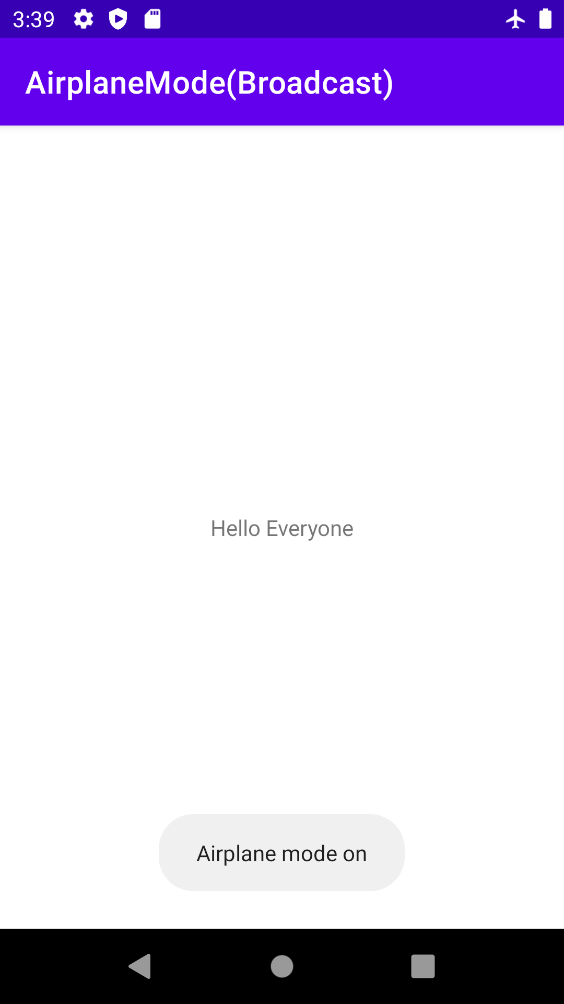
CONCLUSION:
Hence Broadcast Receiver is implemented successfully.

Practical 9:
AIM: Create an android app to show Notifications and Alarm manager.

ALARM MANAGER

activity_main.xml
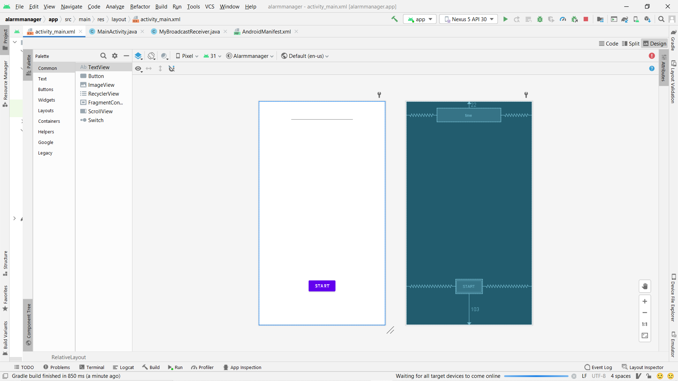
<?xml version="1.0" encoding="utf-8"?>
<RelativeLayout xmlns:android="http://schemas.android.com/apk/res/android"
xmlns:app="http://schemas.android.com/apk/res-auto"
xmlns:tools="http://schemas.android.com/tools"
android:layout_width="match_parent"
android:layout_height="match_parent"
android:background="#7FFFD4"
tools:context=".MainActivity">
<Button
android:id="@+id/button"
android:layout_width="wrap_content"
android:layout_height="wrap_content"
android:text=" Start"
android:layout_alignParentBottom="true"
android:layout_centerHorizontal="true"
android:layout_marginBottom="103dp" />
<EditText
android:id="@+id/time"
android:layout_width="wrap_content"
android:layout_height="wrap_content"
android:layout_alignParentTop="true"
android:layout_centerHorizontal="true"
android:layout_marginTop="22dp"
android:ems="10" />
</RelativeLayout>

AndroidManifest.xml
<?xml version="1.0" encoding="utf-8"?>
<manifest xmlns:android="http://schemas.android.com/apk/res/android"
package="com.example.alarmmanager">
<application
android:allowBackup="true"
android:icon="@mipmap/ic_launcher"
android:label="@string/app_name"
android:roundIcon="@mipmap/ic_launcher_round"
android:supportsRtl="true"
android:theme="@style/Theme.Alarmmanager">
<receiver
android:name=".MyBroadcastReceiver"
android:enabled="true"
android:exported="true"></receiver>
<activity
android:name=".MainActivity"
android:exported="true">
<intent-filter>
<action android:name="android.intent.action.MAIN" />
<category android:name="android.intent.category.LAUNCHER" />
</intent-filter>
</activity>
</application>
</manifest>

MyBroadcastReceiver.java
package com.example.alarmmanager;
import android.content.BroadcastReceiver;
import android.content.Context;
import android.content.Intent;
import android.media.MediaPlayer;
import android.widget.Toast;
public class MyBroadcastReceiver extends BroadcastReceiver {
MediaPlayer mp;
@Override
public void onReceive(Context context, Intent intent) {
mp=MediaPlayer.create(context, R.raw.alarm);
mp.start();
Toast.makeText(context, "Ringing......", Toast.LENGTH_LONG).show();
}
}
MainActivity.java
package com.example.alarmmanager;
import androidx.appcompat.app.AppCompatActivity;
import android.app.AlarmManager;
import android.app.PendingIntent;
import android.content.Intent;
import android.os.Bundle;
import android.view.View;
import android.widget.Button;
import android.widget.EditText;
import android.widget.Toast;
import android.os.Bundle;
public class MainActivity extends AppCompatActivity {
Button start;
@Override
protected void onCreate(Bundle savedInstanceState) {
super.onCreate(savedInstanceState);
setContentView(R.layout.activity_main);
start= findViewById(R.id.button);
start.setOnClickListener(new View.OnClickListener() {
@Override
public void onClick(View view) {
startAlert();
}
});
}
public void startAlert(){
EditText text = findViewById(R.id.time);
int i = Integer.parseInt(text.getText().toString());
Intent intent = new Intent(this, MyBroadcastReceiver.class);
PendingIntent pendingIntent = PendingIntent.getBroadcast(
this.getApplicationContext(), 0, intent, 0);
AlarmManager alarmManager = (AlarmManager) getSystemService(ALARM_SERVICE);
alarmManager.set(AlarmManager.RTC_WAKEUP, System.currentTimeMillis()
+ (i * 1000), pendingIntent);
Toast.makeText(this, "Alarm start in " + i + " seconds",Toast.LENGTH_LONG).show();
}
}

OUTPUT-
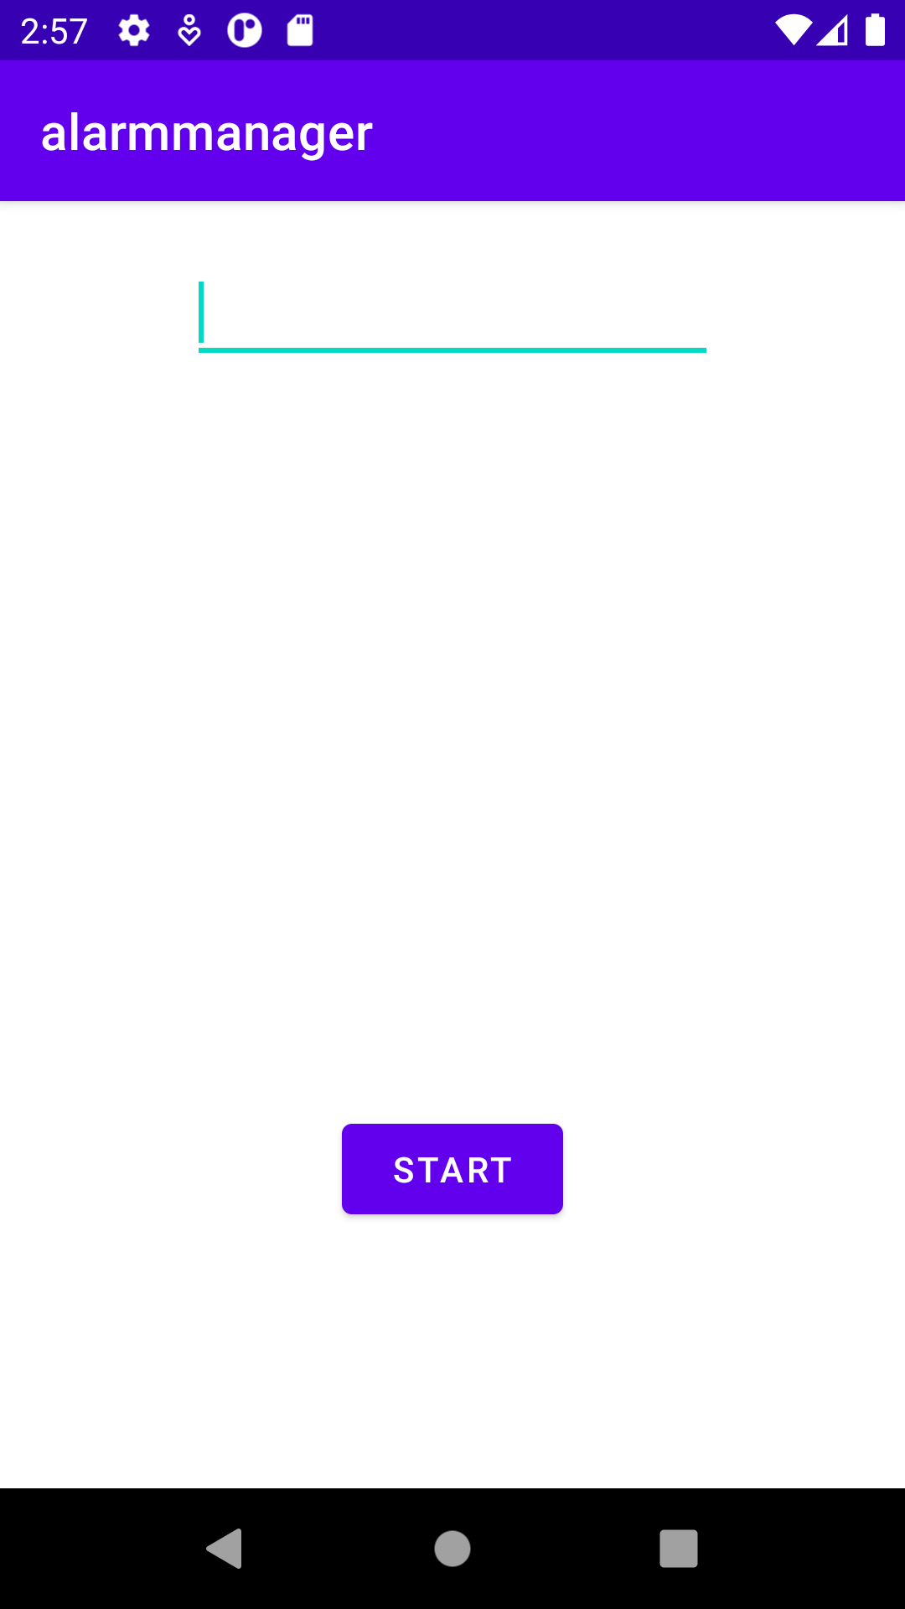
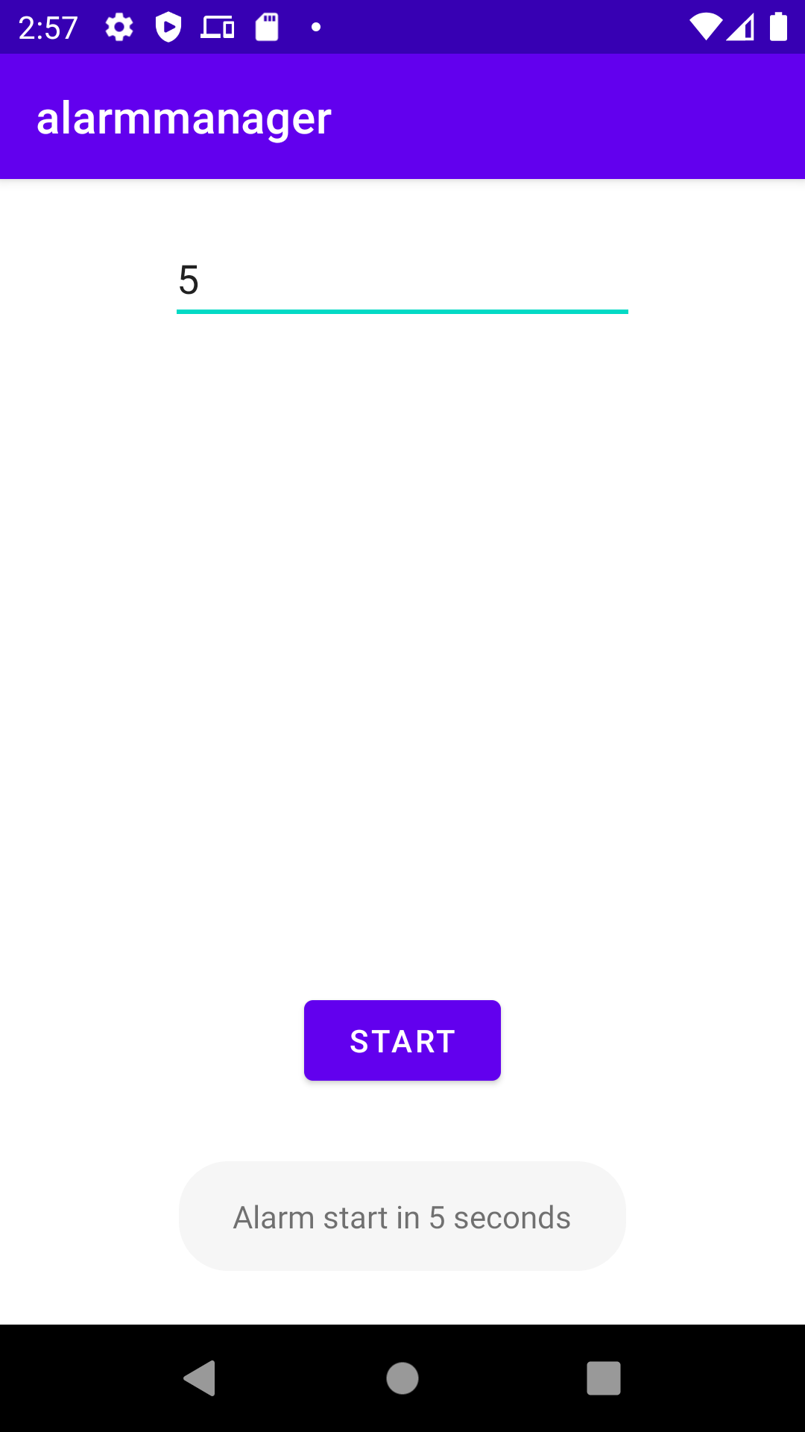

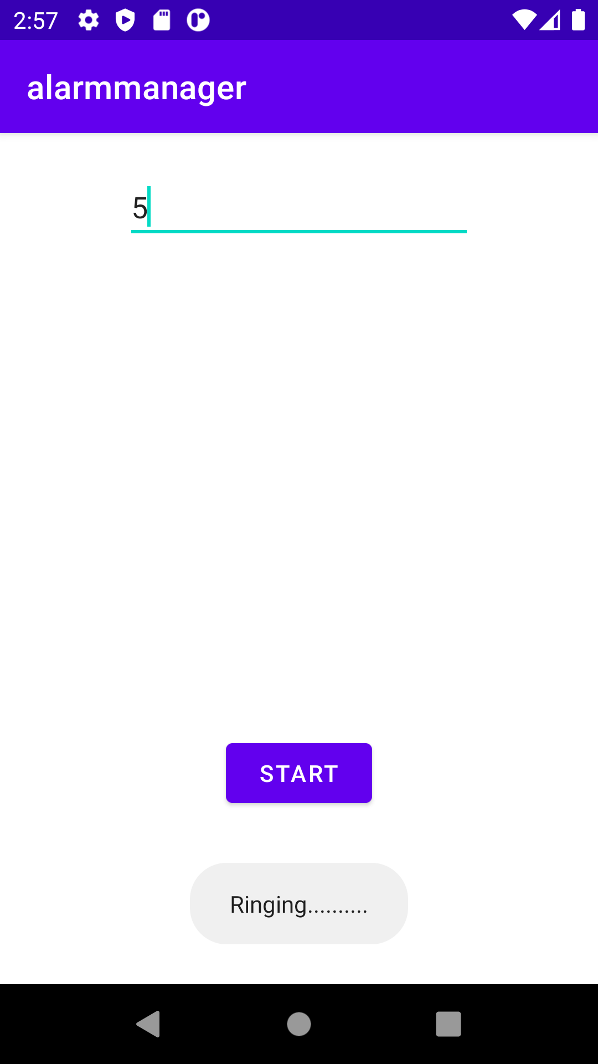
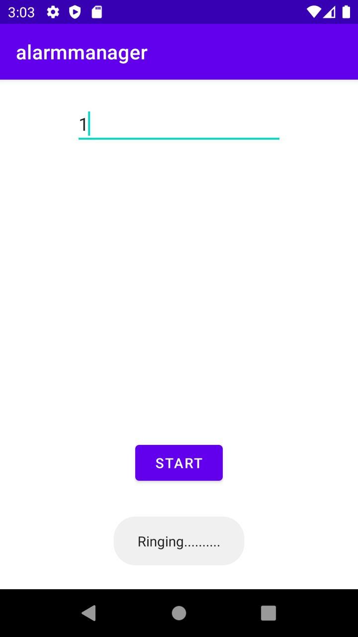
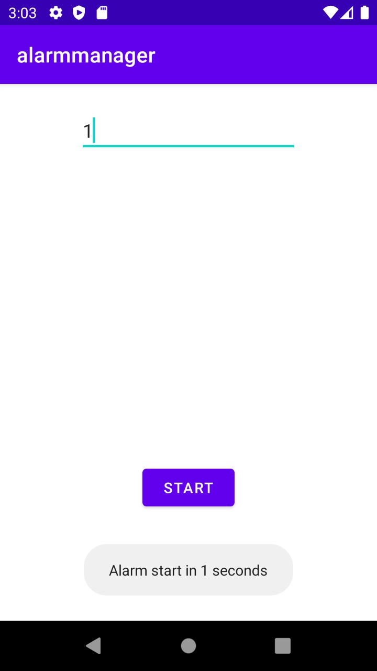

CONCLUSION:
Hence Alarm manager is implemented successfully

